**HARDWARE SPECIFICATIONS**

## **TECHNICAL SPECIFICATIONS OF THE GOPIGO KIT:**

* Compatible with all versions of the Raspberry Pi (board not included in the kit)
* Programming languages: Python, Scratch, Java, NodeJS, C/C++
* Compatible with Lego Technic parts
* Operating voltage: 7–12V
* External interfaces:
  + I2C ports: 2 Grove ports connected to the Raspberry Pi I2C bus through a level conversion chip
  + Serial ports: 1 Grove port connected to serial pins on the Raspberry IP through a level conversion chip
  + Analogue/digital ports: 2 Grove ports connected to the GoPiGo3 microcontroller (ATSAMC20J)

**THE GOPIGO3 BASE KIT INCLUDES:**

* GoPiGo3 board
* Chassis materials: frame, 66.5 mm wheels, various hardware
* Motors
* Encoders: 2 magnetic encoders with 6 pulse counts per rotation (with 120:1 gear reduction, i.e. 720 pulses per wheel rotation)
* Power battery pack and cables

**GOPIGO3 BOARD TOP VIEW:**

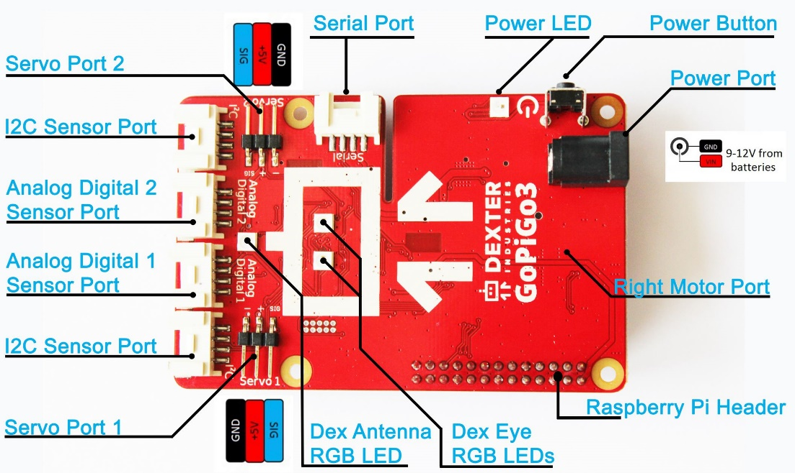

**GOPIGO3 BOARD BOTTOM VIEW:**

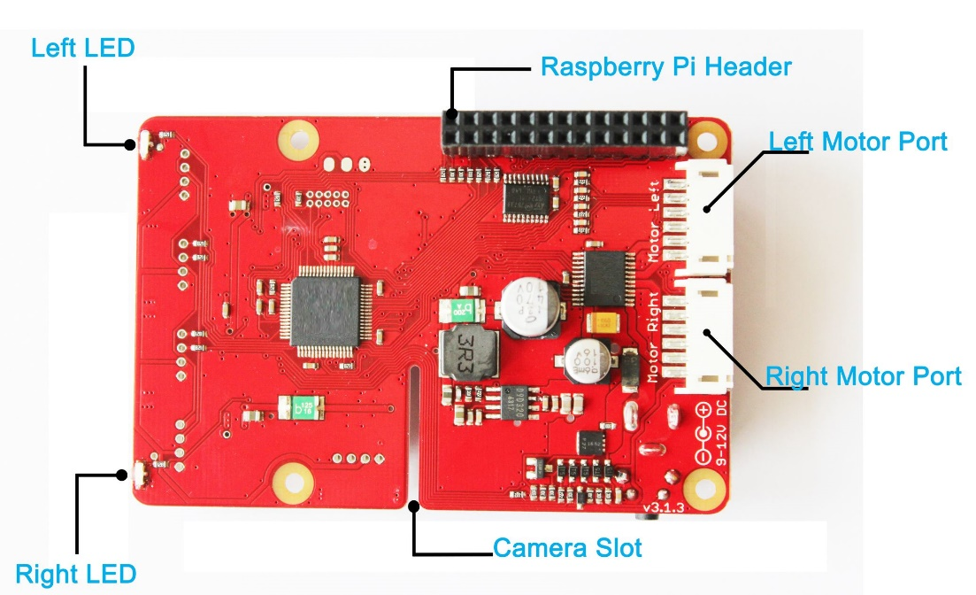

**GOPIGO3 KIT AFTER ASSEMBLY:**

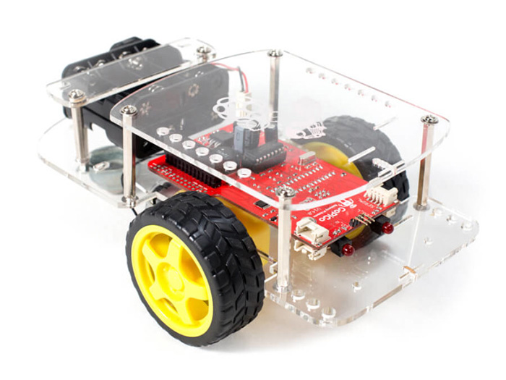

**RASBERRY PI B+ SPECIFICATIONS:**

* Dual step-down (buck) power supply for 3.3V and 1.8V
* 5V supply has polarity protection, 2A fuse and hot-swap protection (so you can plug/unplug USB without resetting the board)
* New USB/Ethernet controller chip
* 4 USB ports instead of 2 ports
* 40 GPIO pins instead of 26. The top/first 26 pins match the original layout, 9 additional GPIO and 2 EEPROM Plate identification pins
* Composite (NTSC/PAL) video now integrated into 4-pole 3.5mm 'headphone' jack
* MicroSD card socket instead of full size SD
* Four mounting holes in rectangular layout
* Many connectors moved around
* Size, 85mm x 56mm
* Processor, Broadcom SoC running at 700MHz (can be overclocked)
* RAM, 512MB soldered on top of the Broadcom chip
* It has power connector, microUSB
* Software - be sure to run the latest Raspbian/NooBs but otherwise the overall Linux software is the same
* First 26-pins of GPIO are the same
* It has a HDMI port
* Audio part of the A/V jack is the same
* Same Camera and DSI Display connector

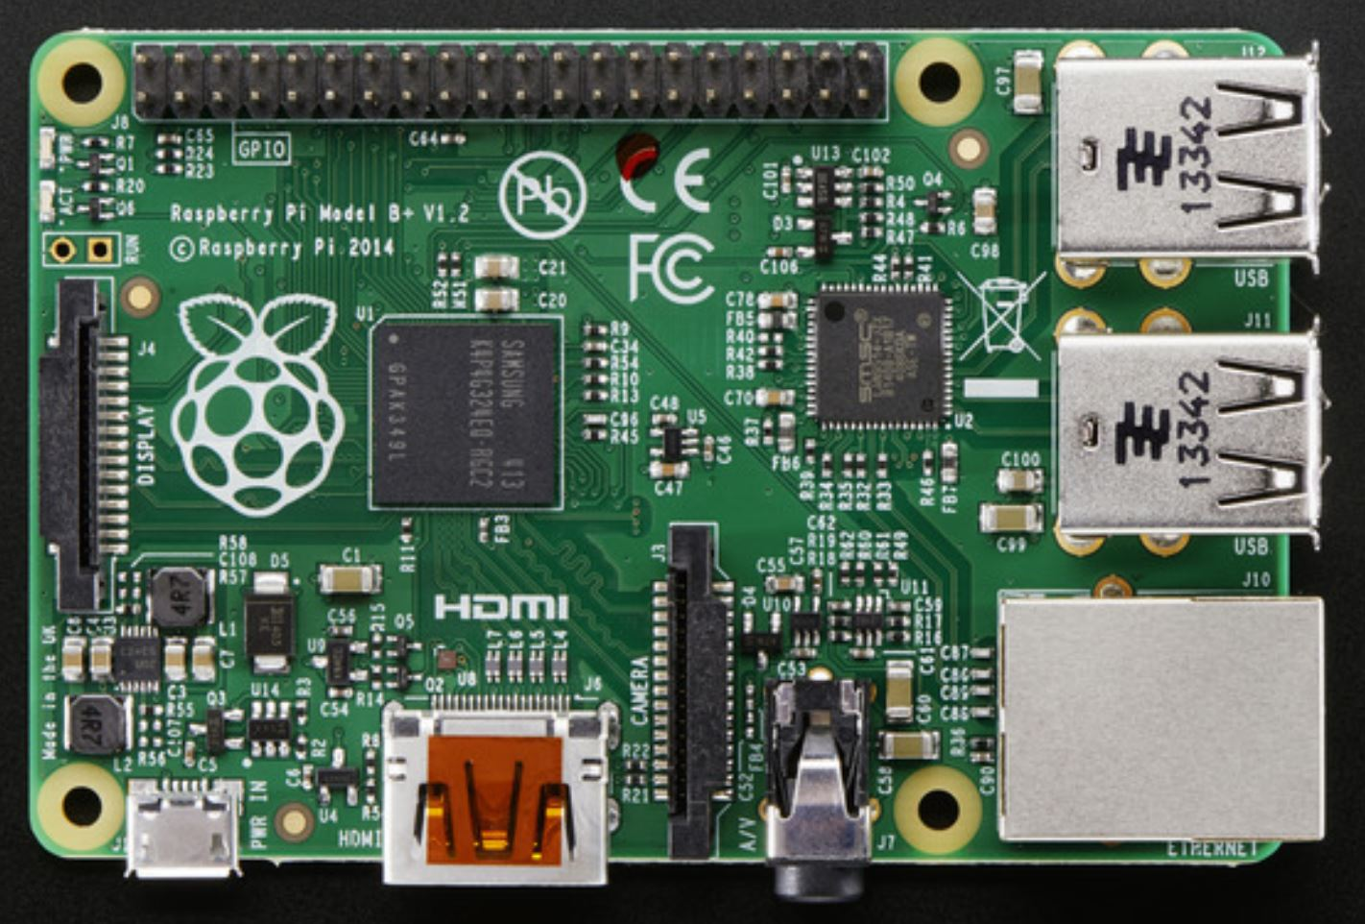

**DISTANCE SENSOR:**

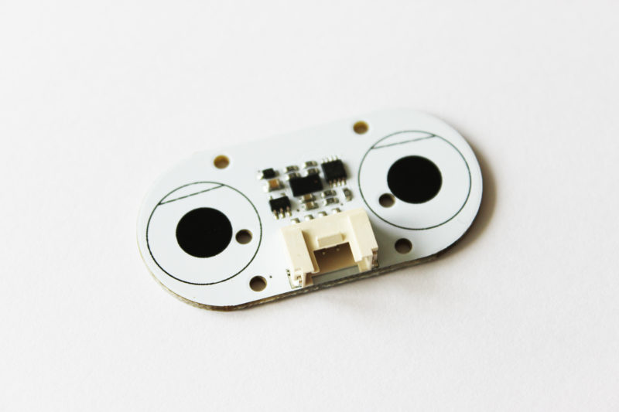

* It runs at 5V
* The distance sensor uses a small laser to determine the distance to an object. The sensor uses the Time of Flight method for a very fast and accurate distance reading
* The distance sensor has 1mm distance precision
* The laser beam cone is 35 degrees wide, and the sensor has 25 degrees of sensitivity
* The sensor range is from < 2cm up to just a little more than 2m

**CAMERA MODULE:**

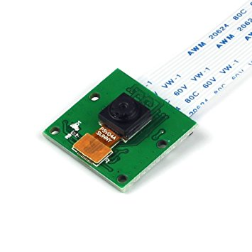

* High-Definition video camera for Raspberry Pi Model A or B, B+, model 2, Raspberry Pi 3
* 5MPixel sensor with Omnivision OV5647 sensor in a fixed-focus lens
* Integral IR filter
* Still picture resolution: 2592 x 1944
* Max video resolution: 1080p